Criminal Face Detection

Ghaneyya Mohamed Alsalmi

Kamla Mohamed Alsalmi

Index

**Introduction1**

Type chapter title (level 2)2

Type chapter title (level 3)3

**Type chapter title (level 1)4**

Type chapter title (level 2)5

Type chapter title (level 3)6

**Codes Explanations:**

Code 1:

In code 1 we imported the images of different faces saved in folder and put it in a list to convert it to an array and reshape it and scale the image so we prepare the data to be used in training the model we will create, after that we create the model with two convolutional layers ,a flatten layer, one hidden layer and out put layer. The we trained the model with the images we prepared previously some images for criminal for example and images for unknown people. Finally we saved the model to use it in code 2.

Code 2:

In code 2 we loaded the model we created before and used it to predict the images we feed using the camera throw function we created to detect faces using haarcascade_frontalface , or the image we provide to test the accuracy of the model.

App.1Py:

In this code we created a server camera using Flask package, and used the code 2 to predict the faces with the live camera and to show us if the person is criminal or not and draw square around the criminal person and the name of that person or word like” criminal , black list,..” and store the name and the time of this person appear on cameras.

Index.html:

In this file we create the web server to open the camera and detect the criminal faces and apply a code to open different cameras of different devices in same page.

Feature Maching

Face Alignment

Input Aligned Face

Feature Extraction

Face Detection

Preprocessing Stage Recognition

Existing database

Stage

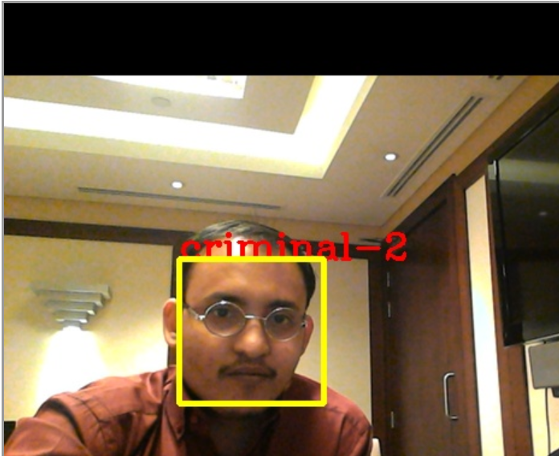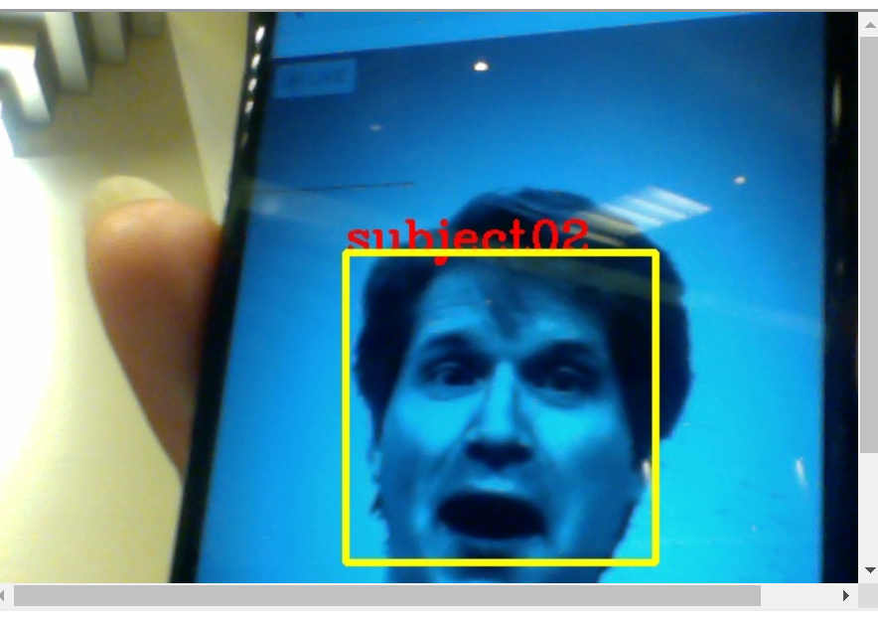

Resources :